Quiz for Exam 3

1. For an undirected graph, the shortest distance between two distinct vertices u and v is equal to the shortest distance between v and u.  
   TRUE
2. 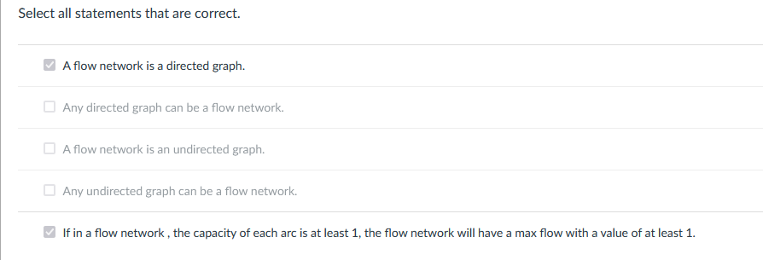
3. Please match algos  
   Rabine-karp  
   text search (or String Matching) problem  
   Djikstra  
   single-source shortest path problem with positive weights  
   Bellman-Ford-Moore  
   single-source shortest path problem wit hall weights  
   Ford-Fulkerson method  
   maximum flow using augmenting paths   
   Edmonds-Karp  
   maximum flow using augmenting paths and BFS traversal
4. 